MILESTONE 2 PROJECT REPORT – DAVID FORKEL
IT4403: ADVANCED WEB AND MOBILE APP
URLs
Homepage - https://itsforkel.github.io/IT4403/
Milestone 2 - https://itsforkel.github.io/IT4403/projects.html
Book Search - https://itsforkel.github.io/IT4403/Milestone2/index.html
My Bookshelf - https://itsforkel.github.io/IT4403/Milestone2/bookshelf.html

Screenshots
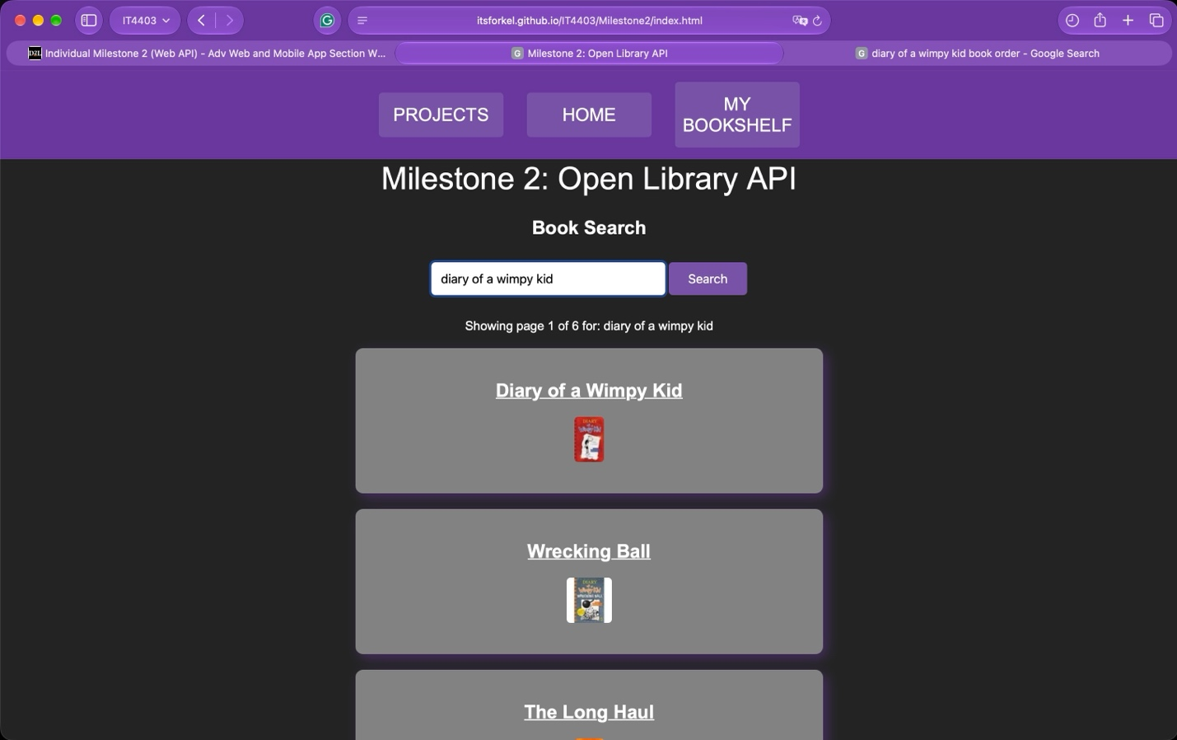
^Screenshot 1: Book Search Page^
This screenshot displays the homepage of the Open Library API application. Users can enter a book title or keyword into the search bar to retrieve information from the Open Library API. JavaScript and jQuery are used to display book titles and covers, with pagination allowing users to navigate through multiple pages of results.

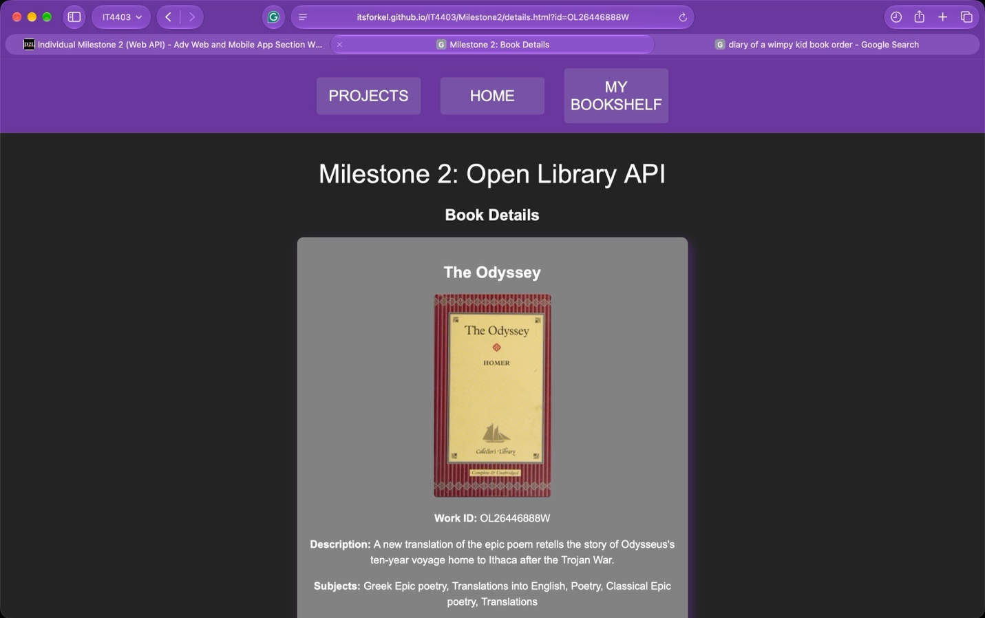
^Screenshot 2: Book Details Page^
This screenshot displays the information retrieved from the Open Library API using a selected book's Work ID. JavaScript and jQuery are used to display the book title, Work ID, description, subjects, and cover image. A link to the book's Open Library record is provided as well.
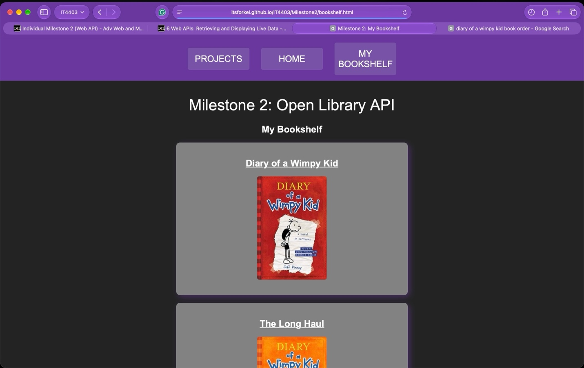
^Screenshot 3: My Bookshelf Page^
This screenshot displays a personal collection of five books selected from Open Library. The books' Work IDs are stored in a JavaScript array and used to retrieve their information from the API. Each book displays its title and cover image, with links to its corresponding Book Details page.

What was the most significant error I encountered?
The most significant error I encountered while working on Milestone 2 was with the book details page. When finishing the code for this page, I made a test link on my website so I could make sure it actually brought up the info of a selected book. This brought me to my error message of “Book Information Unavailable”. I thought this was due to an error with getting the information from the Open Library API.
When I looked into the URL portion of my test link, I realized my issue was not with the API but with the URL I was accessing the book details page with. It seemed like a silly issue, but the URL requires a Work ID to retrieve information on a specific book, and I neglected to include a test book Work ID when typing the test link. In short, there wasn’t any book to be searched for in the URL, so my link kept throwing the same fallback message.
I resolved the issue by accessing the book details page through the book search results, which included a Work ID into the URL. I learned to pay better attention to exactly what my code needed to access and gave me a better understanding of URL parameters between two webpages!

